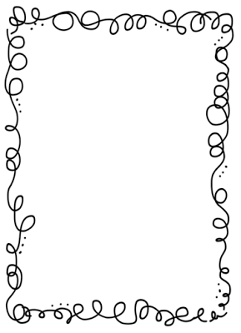Mrs. Crawford’s Weekly Newsletter

Classroom Corner

Math: We will be working on finding fractions of a set.

Reading: This week we are reading “Building for Space Travel”. Question of the week: If you were designing a spaceship, how could you use math to figure out what the ship should be like?

Writing: We are writing compare and contrast papers on space travel.

Science: We are learning about levers and pulleys.

Social Studies: Lewis and Clark

This quarter most of our class reached their AR goals. Way to go!!!

Keep reading 30 minutes a night!

Spelling List

1. acknowledge 11. numbness
2. align 12. outlook
3. bombs 13. withstood
4. climbing 14. wrathful
5. crooked 15. wreckage
6. design 16. recent
7. fasten 17. resent
8. gnash 18. thorough
9. handbook 19. through
10. know-how

Remember to do one spelling activity a night from the contract, then hand in all four activities on Friday.

Upcoming Events

PE is on Wednesday wear tennis shoes.

Feel free to contact me at any time. My email address is [crawforf@d93.k12.id.us](mailto:crawforf@d93.k12.id.us), my phone number is 208-552-0866 ext. 3343. I will usually get back to you at the end of the day or early the next morning.