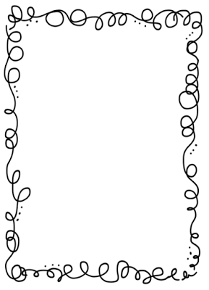Mrs. Crawford’s Weekly Newsletter

Classroom Corner

Math: We are learning about multiplication and division. Make sure your student is practicing their math facts.

Reading: We are working on character traits while reading “*The Deer, Mouse and Farmer”.*

Social Studies: Native Americans in Idaho

Writing: We are currently learning how to write opinion papers.

Science: We will be starting an unit on levers and pulleys.

Montana is our student of the week. She is an amazing help in the classroom and always has a positive attitude. Thank you Montana!!

Keep reading 30 minutes a night!

Upcoming Events

Early release is on Wednesday

PE is on Monday wear tennis shoes.

Red ribbon weeks starts next week.

Spelling List

1. flock
2. hush
3. lack
4. stuck
5. marsh
6. shriek
7. pluck
8. course
9. coarse
10. affect
11. effect

Remember to do one spelling activity a night from the contract, then hand in all four activities on Friday.

Feel free to contact me at any time. My email address is [crawforf@d93.k12.id.us](mailto:crawforf@d93.k12.id.us), my phone number is 208-552-0866 ext. 3343. I will usually get back to you at the end of the day or early the next morning.