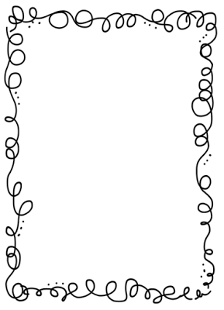Mrs. Crawford’s Weekly Newsletter

Our student spotlight goes to Hannah. Hannah is a thoughtful student, who always does her best. Thank you so much Hannah!!

Make sure you read twenty minutes a night.

Classroom Corner

Math: We will be learning addition and subtraction to the 10,000 place.

Reading: This week’s concept is main idea and author’s purpose. Our Unit question is: Why are traditions an important part of our culture? Talk about traditions your family does.

Science: Animal Habitats, we will be learning about dwarf frogs this week.

Social Studies: Idaho Symbols

Spelling List

1. admire 11. rapid
2. background 12. sacrifice
3. catalog 13. standard
4. contrast 14. translate
5. factor 15. travel
6. grasp 16. than
7. Impact 17. then
8. Mainland 18. to
9. Passage 19. too
10. Practice 20. two

Feel free to contact me at any time. My email address is [crawforf@d93.k12.id.us](mailto:crawforf@d93.k12.id.us), my phone number is 208-552-0866 ext. 3343. I will usually get back to you at the end of the day or early the next morning.

Upcoming Events

Monday is PE, please wear tennis shoes.

Tuesday is music.

Library is on Thursday.