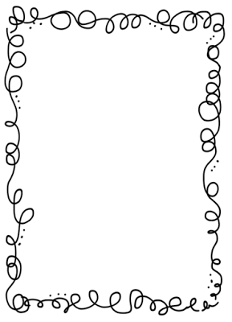Mrs. Crawford’s Weekly Newsletter

Hannah was our student of the week. She is extremely thoughtful and a huge help in the class. Thank you so much Hannah!!!

Keep reading 30 minutes a night!!!

Classroom Corner

Math: We will be finishing up comparing numbers to 10,000.

Reading: This week’s concept is main idea and author’s purpose. Our Unit question is: Why are traditions an important part of our culture? Talk about traditions your family does.

Writing: We are writing opinion pieces about our classroom pet.

Science: Last week we received our frogs, this week we will learn all about their habitats.

Spelling List

1. blossom 11. pottery
2. concrete 12. probably
3. conflict 13. process
4. costume 14. proper
5. cottage 15. solemn
6. fond 16. lay
7. hostile 17. lie
8. mock 18. passed
9. modest 19. past
10. novel

Feel free to contact me at any time. My email address is [crawforf@d93.k12.id.us](mailto:crawforf@d93.k12.id.us), my phone number is 208-552-0866 ext. 3343. I will usually get back to you at the end of the day or early the next morning.

Upcoming Events

We will have a student teacher this year. Her name is Mrs. Kisner.

Grandparent’s Day is 9/22.