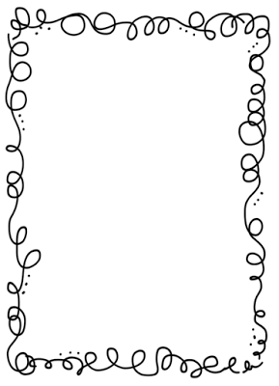Mrs. Crawford’s Weekly Newsletter

Encourage your student to ask the who, what, why, when and how, questions when reading a story.

Keep reading 30 minutes a night!!!

Classroom Corner

Math: We are finishing up place value and heading into factors and multiples of numbers.

Reading: We are learning about the plot of a story, what happened at the beginning, middle, and end of a story. Why are traditions an important part of our culture?

Social Studies: We are studying Idaho History.

Science: This week we will start to learn about fiddler crabs.

Spelling List

1. artistic 11. inspire
2. assist 12. instruct
3. blush 13. puzzle
4. budge 14. rigid
5. culture 15. upward
6. differ 16. angel
7. fundamental 17. angle
8. humble 18. set
9. illustrate 19. sit
10. immense

Feel free to contact me at any time. My email address is [crawforf@d93.k12.id.us](mailto:crawforf@d93.k12.id.us), my phone number is 208-552-0866 ext. 3343. I will usually get back to you at the end of the day or early the next morning.

**Upcoming Events**

**PE is on Monday**

**Grandparent’s day is on 9/22.**