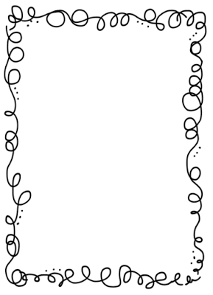Mrs. Crawford’s Weekly Newsletter

Classroom Corner

Math: We will start our multiplication unit. Your student will be multipling three digit by two digit numbers.

Reading: We are learning about idioms, for example: The early bird gets the worm. We are also working on main idea and the supporting details of a story. Why are traditions an important part of our culture?

Science: We are still examining our fiddler crabs, they are cute.

Social Studies: We are starting to learn about the Native Americans who live in Idaho.

Justin is our student of the week. He is hard working and always up for a challenge. Thank you Justin for giving the class 110 % all of the time.

We are still working on reaching our AR Goals.

Keep reading 30 minutes a night!!!

Spelling List

1. same
2. whale
3. flake
4. grape
5. stage
6. mail
7. pain
8. train
9. day
10. say
11. play
12. may

Upcoming Events

PE is on Monday.

Feel free to contact me at any time. My email address is [crawforf@d93.k12.id.us](mailto:crawforf@d93.k12.id.us), my phone number is 208-552-0866 ext. 3343. I will usually get back to you at the end of the day or early the next morning.